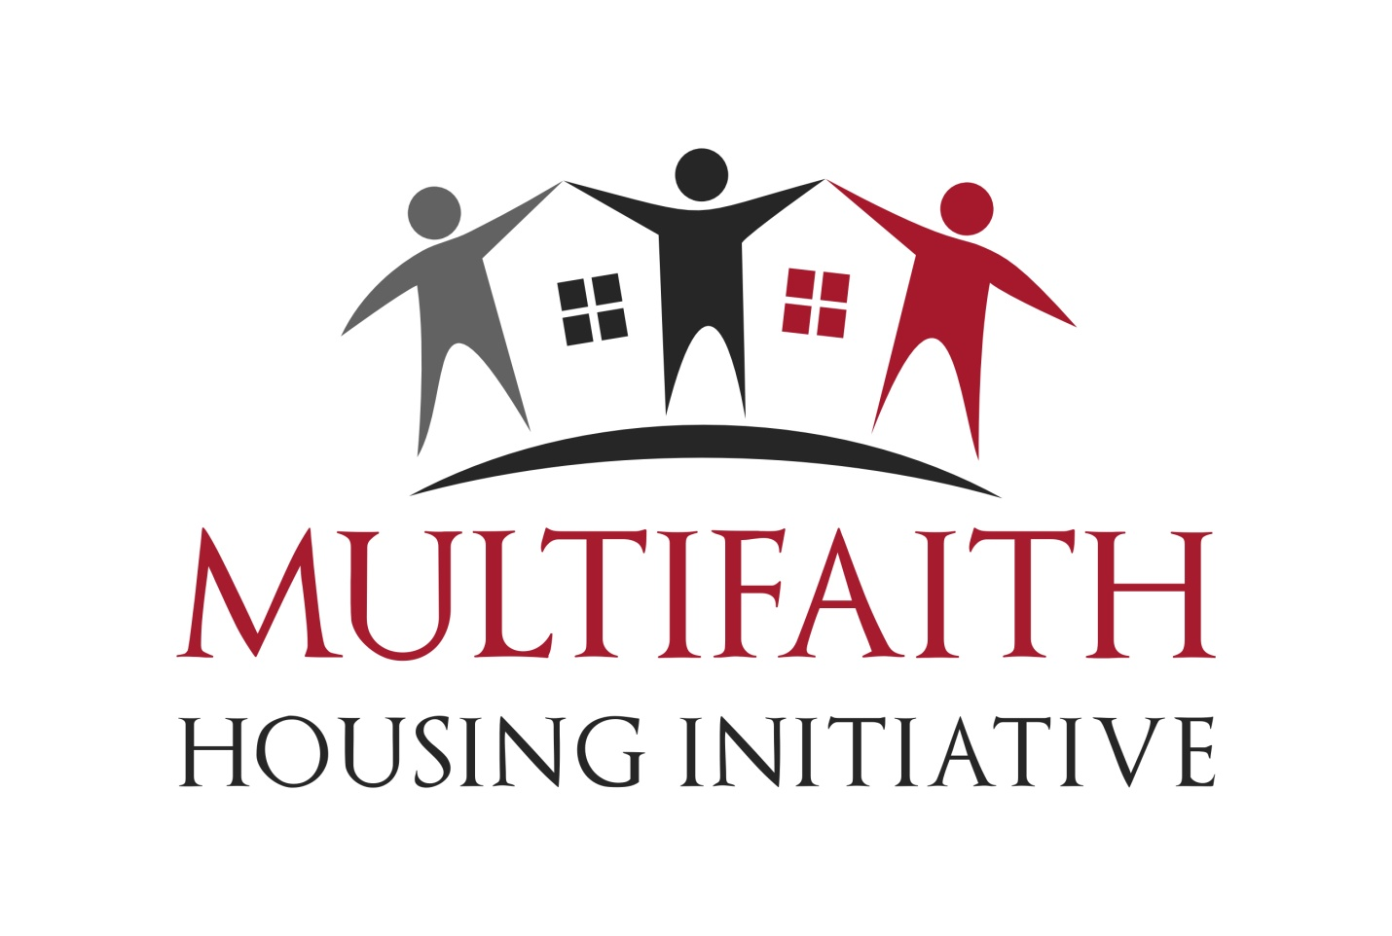

BOARD OF DIRECTORS’
BRIEFING BOOKLET
January 25, 2016

Mission and Values
The mission of the Multifaith Housing Initiative is to provide and to promote affordable home space, to encourage harmonious relations amongst tenants of diverse backgrounds and to mobilize the resources of faith communities and others for these purposes.
MHI is a faith-based charitable organization whose goal is to raise awareness about the affordable housing crisis and to mobilize faith communities and others to work together to address it. MHI affirms the values and statements in the Charter for Compassion and is supported morally in this by faith community leaders in Ottawa who are our patrons, including those of Christian, Jewish, Muslim, Hindu and Unitarian backgrounds. Our membership includes over 60 different faith communities and faith-based organizations. Interfaith discussion about affordable housing began in Ottawa in 2001. MHI was incorporated federally as a non-profit charitable organization in late 2002 and the organization purchased its first building in 2005.
We provide affordable housing for households whose income falls below the low income cut-off (LICO), which ranges from $23,298 for one person to $61,656 for 7 or more in a household. Over the past 10 years, we have learned that the actual provision of housing through grass-roots action is a very effective strategy to raise awareness about the lack of affordable housing and to convince people to work together to seek solutions. This is not surprising given that generally, people learn through reflecting on their personal experience and become mobilized when they see the human cost that social problems generate.
MHI now owns and manages forty-one affordable housing units in three different areas:
- Kent House: an older building in downtown Ottawa with 2 bachelors and 3 one-bedroom apartments;
- Somerset Gardens: 10 one-bedroom condominium units in downtown Ottawa; and
- Blake House: an apartment complex on a quiet street in Vanier with 26 units including 2 bachelor, 6 one-bedroom, 9 two-bedroom and 9 three-bedroom units.

Housed in these units is a cross-section of people in Ottawa who are badly in need of affordable housing. These include people who were living in shelters, and people who were at risk of homelessness: young people returning to school, seniors on fixed low incomes, people dependent on social assistance and disability payments, individuals and families who are working poor. MHI has service agreements with the City of Ottawa governing twenty-one of our 41 units, and tenants for these units are selected through the Housing Registry. We rent the rest of our units privately to people who fit within our mandate. A list of interested applicants is kept in the MHI office. Units for this group are subsidized through income generated by our operations and donations.
In 2017, MHI will own an additional 98 units in The Haven, MHI’s new development currently under construction in the Longfields area of Barrhaven. There will be 29 one-bedroom, 38 two-bedroom, 27 three-bedroom, and 4 four-bedroom units in two apartment buildings, back-to-back townhomes, and row townhomes.
Because MHI provides housing for people who really ought to be housed in rent-geared-to-income (RGI) units (where they would pay only 30% of their gross income for rent),we use volunteer labour in addition to a professional property manager. This allows MHI to maintain our grass-roots nature, reduce operational costs, and help maintain lower rents. Nevertheless, without deep subsidies from government, it is impossible to provide rent levels that meet RGI targets in all cases. Instead, our goal is to rent our units at 70% of average market rent. In addition, we have a practice of not raising the rent of households who are living in a 70% of market rental unit and paying more than 35% of their gross income for rent.
Despite our best efforts to provide lower rents, many of our tenants struggle with a number of issues associated with poverty and can still be at risk of losing their housing. For this reason, MHI offers each tenant household the support of a trained volunteer who is able to provide support on an as-needed basis.
Given the challenges, both financial and human, there is no question that the work of MHI is complex and our goals will be difficult to achieve. However, the challenges are equal to the reward in seeing people able to settle into safe and well-maintained homes, get on with their lives, and achieve their own goals. While it is not necessarily the goal of MHI, we often see tenants who are able to improve their circumstances and ultimately move out into the private marketplace.
Organizational Structure
MHI is a grass-roots, volunteer-led, highly collegial and entrepreneurial organization. The Board of Directors establishes goals in light of MHI’s mission and values, develops MHI’s strategic direction, and sets policies to guide the work of MHI. These goals are developed through consultation with committee members and reviewed on an annual basis. MHI committees then develop and implement these strategies either directly or indirectly through working teams.
MHI currently has the following staff members: a full-time Executive Director, plus an Office Manager, a Manager of Volunteers, and a Manager of Fund Development, all of whom work part-time. When feasible, MHI employs tenants to do superintendent/custodial work. MHI also contracts LSM Services to manage its properties and Dynapro to handle the book-keeping. Our office is located at 206-404 McArthur Avenue and our hours are 9 a.m. to 1 p.m. five days a week or by appointment.
The Executive Director is an ex officio member of each committee, acts in an advisory role to the committee chairs, and oversees the work of MHI on behalf of the Board. This ensures that the committees are following the strategic direction and that there is overall co-ordination of the work across MHI. The ED also works with Board members to develop the capacity of the committees to meet their responsibilities. The Board selects, evaluates and supports the ED.
At present, MHI has eight standing committees: Executive Committee, Finance Committee, Communications Committee, Fund Raising Committee, Development Committee, Human Resources Committee, Housing Management Committee, and Membership and Outreach Committee. A Nominations Committee is constituted each year in December. The terms of reference for these committees are available. Decisions are made by consensus –i.e. the majority in agreement and the remaining members able ‘to live with’ the decision --and recorded in the minutes.
MHI (now thirteen years old) is still a relatively young organization and is an exciting organization to be part of. MHI is best suited for compassionate people who have a strong sense of social justice, who are team players, and who enjoy creative thinking and experiential learning. Diversity of thinking is valued –indeed celebrated –as our greatest resource. We recognise that together, as people of faith, we are inspired by what is more than any of us can describe or imagine.
Financial Status
MHI’s most recent audited Statement and Annual General Report are available on the MHI website.
Responsibilities of Board Members
MHI Board members have a dual role: 1) they bring skill and experience to support the work of MHI, and 2) they encourage support for and involvement with MHI by others, including their own faith community when relevant. They are expected to contribute approximately 10 hours of volunteer time per month. Some, particularly the Executive, give more depending on their availability and interests. Board members are also expected to be strongly committed to our strategic direction, including our fundraising activities. We ask that Board members lead by example by including MHI in their charitable giving, and making a donation to MHI which is significant relative to their own personal circumstances.
Board member responsibilities include the following:
- Regularly attend Board meetings and other MHI-related events: The Board meets the last Thursday of the month from 6:00 to 8:00 p.m. (except during the month of July). MHI holds up to two retreats per year on a Sunday afternoon. In addition, MHI sponsors a National Housing Day event (usually on the third Sunday of November) and its annual fund raising walk, the Tulipathon (on the first Sunday in May).
- Participate actively and respectfully in Board meetings: Each Board meeting begins with a reflection provided by one of the members in turn. This is based on the insights his or her faith tradition has to offer regarding our mission and grounds us in a sense of shared responsibility for responding to people in need in our community.
- Stay informed about Board and committee matters by reviewing the minutes and reports provided, and prepare well to make comments and decisions at Board meetings: Most material for Board meetings is circulated well in advance. The agenda is prepared by the Executive Committee (EC) which meets the Thursday before the Board meeting.
- Become an active member of one of the Standing Committees: Each standing committee normally meets once a month for about 2 hours, usually in the first or second week. Committees are the heart and soul of MHI. Committees may or may not be chaired by a Board member. However, one Board member is always designated as the communication link between the Board and the committee.
- Approve and monitor the budget: MHI’s fiscal year is November 1 to October 31. Currently our operating budget is approximately $500,000 per year. Our books are kept according to generally-accepted accounting principles and audited annually as required by Industry Canada.
- Volunteer for and willingly accept assignments and complete them thoroughly and on time: MHI members are highly committed to growth. The accomplishment of MHI’s strategic plan depends upon Board members, staff and volunteers alike having confidence that people will keep their commitments to the best of their ability.
- If relevant, cultivate the support of the faith community to which you belong: As a coalition of faith communities and others from across the city, MHI depends upon the active support of its members both financially and as volunteers.
- Participate in fundraising for the organization: Fundraising is essential to realizing our mission. Acquisition of property or property development for housing is capital intensive and the revenues from our tenancies cannot cover all of our costs. Every Board member should be prepared to participate in some aspect of fundraising, whether it be an actual “ask” for money, helping with associated administrative activities, or simply taking the time to thank those who have made a significant donation.
Presently, there are two aspects to our fundraising activity: on-going and a capital campaign. Our ongoing efforts are our annual membership renewal (or invitation to become a new member) and our Tulipathon. In late fall or early in the new year, we mail out a request to faith communities and faith-based organizations asking them to renew their membership or to join MHI and, if possible, make an additional donation. On the first Sunday of May, we hold our “Tulipathon,” in which our member faith communities walk together to raise money.
In March of 2013, we launched a 2-year major capital campaign “A Place to Call Home” and achieved our goal of $500,000. MHI is about to launch Phase 2 of this campaign, to raise an additional $1,000,000 to support the development of 98 units of affordable housing in Barrhaven.
- Ensure compliance with all legislative and statutory duties and obligations: Many different pieces of legislation and statutory duties apply to MHI with regard to our being incorporated as a non-profit charity, to our being an employer, and to our providing affordable rental housing for people who are disadvantaged in our society.
- Abide by the terms and conditions in contractual arrangements and funding agreements (see previous item): MHI has benefitted from receiving significant amounts of money through organizations such as United Way, Trillium and other granting agencies, as well as the City of Ottawa and hopes to continue to do so. These benefits come with regular reporting requirements.
- In all matters, work for the good of Multifaith Housing Initiative: Board members, staff, committees and volunteers have authority to take action on behalf of MHI only if they have been given this by the Board as a whole. The Board remains responsible for the impact of such actions. A Board member also has an obligation to declare a conflict of interest in situations where: 1) the member might benefit directly or indirectly from a decision taken by the Board, or 2) where he or she has made a commitment to a competing non-profit or charitable organization.
- Make your best effort to complete the term of office to which you are elected: Board members are elected for a two-year period. This can be renewed twice for a total of six years. Our hope is that Board members will seek to contribute a lasting legacy to the organization and set a high bar for others to follow by renewing their terms and thereby gaining the experience needed to provide strong leadership.

Orientation

When a new Board member is elected, a returning Board member will act as a mentor and provide further orientation to the work of MHI in general, and provide context for the particular issues being dealt with at the time of his or her election.

All Board members are covered by Directors and Officers Liability Insurance and are also insured against any injury incurred as a result of participating in any MHI activity, including travel to and from that activity.

February 2016

MULTIFAITH HOUSING INITIATIVE

Agreement to allow my name to stand for election
to the Board of Directors at the next
Annual General Meeting
April 3, 2016 at 3:00 p.m.

Attention: Gay Richardson, Chair, Nominating Committee

I have read and understood the MHI Board Briefing Booklet describing the role and responsibilities of an MHI board member and would be pleased to accept the nomination of the nominating committee for this position.

Please find attached a brief synopsis of my CV.

Name: ______________________________________________

Mailing Address: ______________________________________________

______________________________________________

Email Address: __________________________Phone number: __________________

Birth date: _______________________________________________
(required by Industry Canada)

Signature: _______________________________________ (Nominee)

Signature: _______________________________________ (Chair of Nominating Committee)

Date: ________________________________________

